**Project Title: TechR Project 1: Dr. Semmelweis and the Discovery of Handwashing**

**Project Overview**:

It was a guided project, hosted on Datacamp.

The objective of the project was to reanalyse the data behind one of the most important discoveries of modern medicine: handwashing.

In this project, I reanalysed the data that made Dr. Semmelweis discover the importance of handwashing in medical procedures.

The first step was looking at the data that made Semmelweis realize that something was wrong with the procedures at Vienna General Hospital.

**Team Members**:

Individual.

**Project Timeline**:

# January 9, 2023 - Start Date.

# January 9, 2024 – Research on various methods for project completion.

# January 10, 2024 – Actual coding complete.

# January 11, 2024 – Documentation and submission of project complete.

**Tools and Technologies Used**:

https://projects.datacamp.com/projects/20

**Dataset Description**:

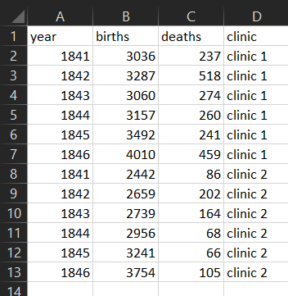

yearly_deaths_by_clinic.csv

**Model Architecture**:

No model was built in this program, as it serves an introduction to the most basic types of machine learning projects.

**Training Process**:

For this process, a Bootstrap Analysis mechanism was used.

In statistics and machine learning, bootstrapping is a resampling technique that involves repeatedly drawing samples from our source data with replacement, often to estimate a population parameter. By “with replacement”, we mean that the same data point may be included in our resampled dataset multiple times.

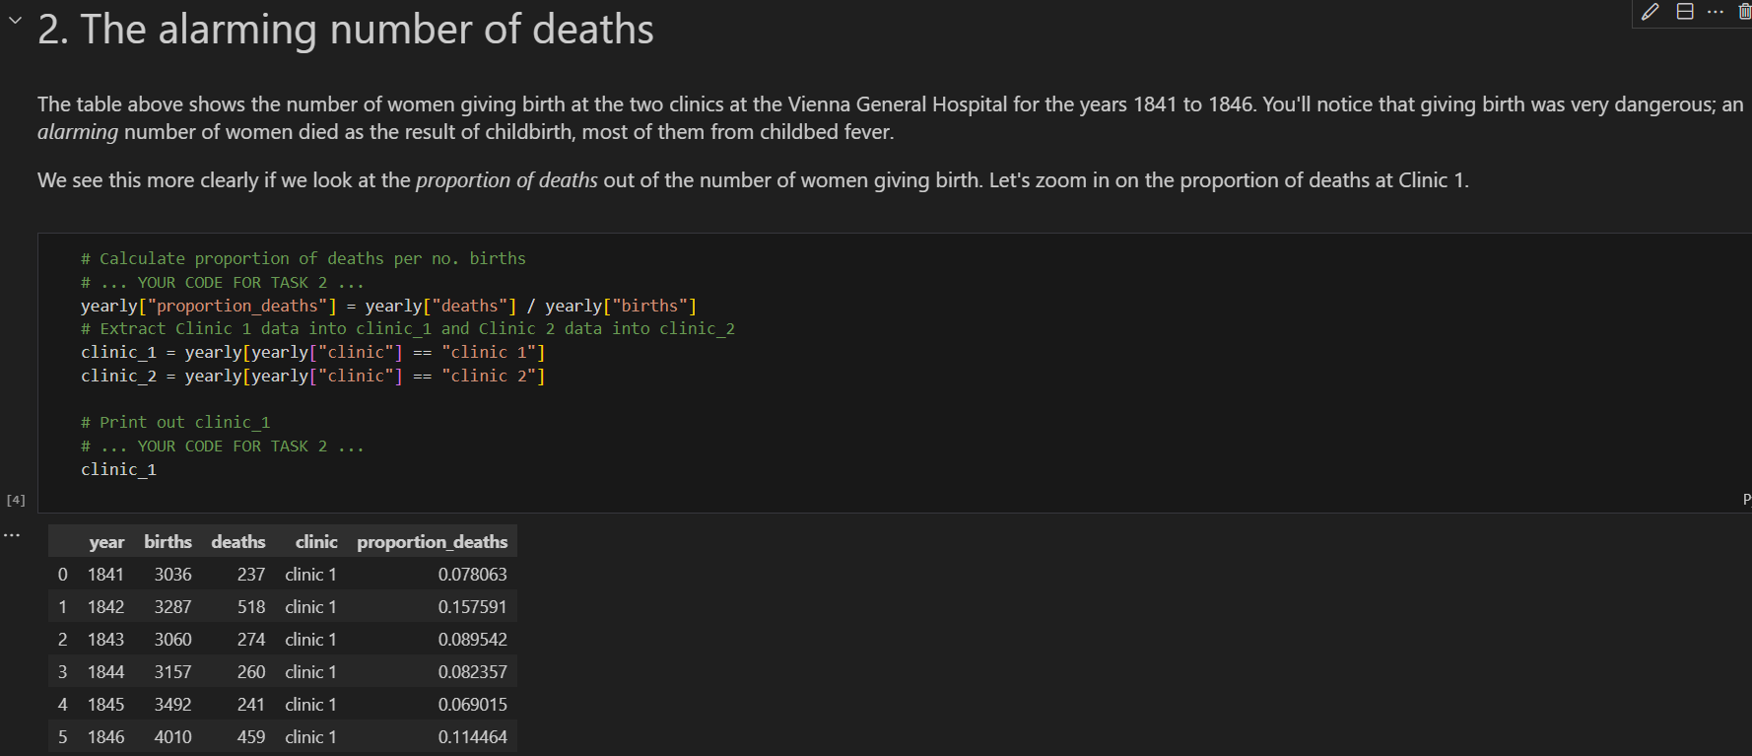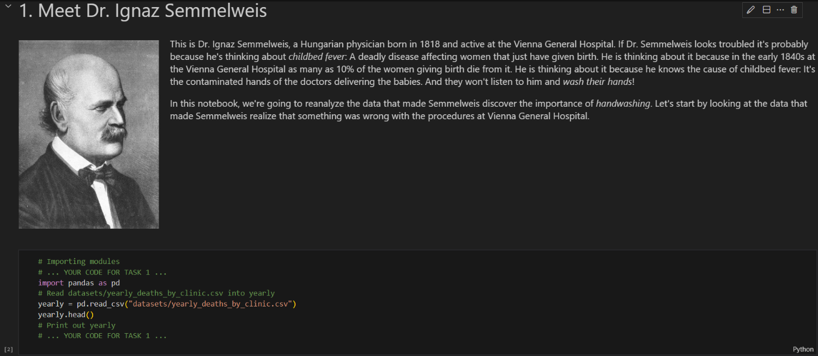**Results**:

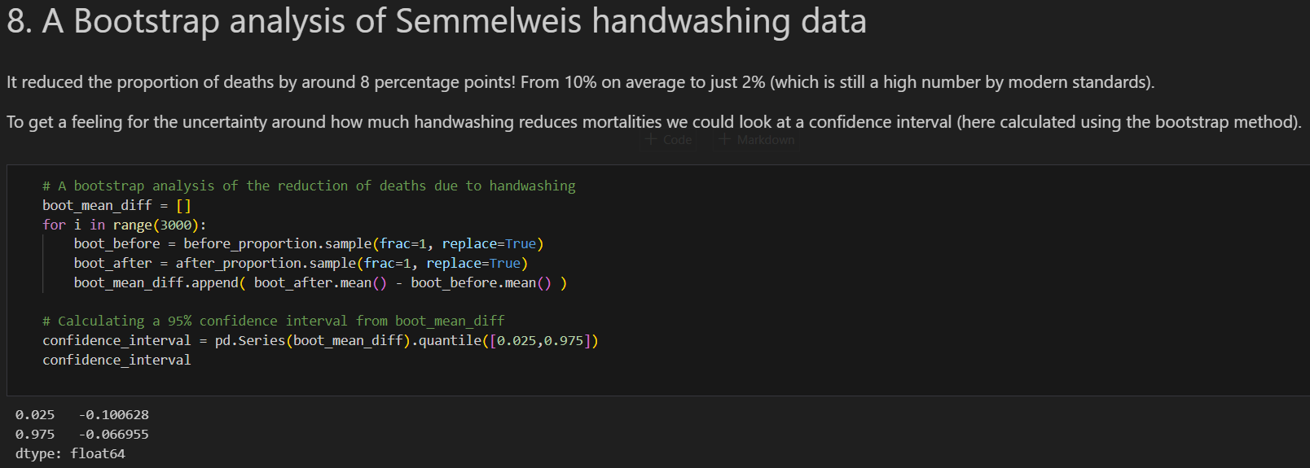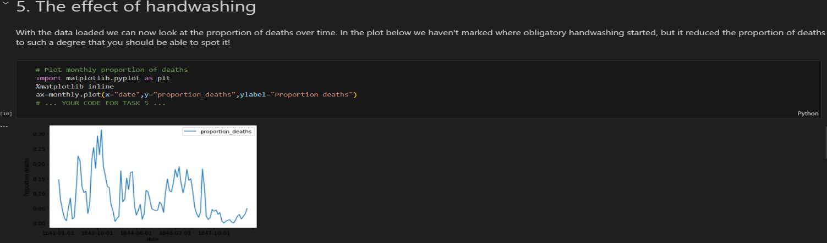

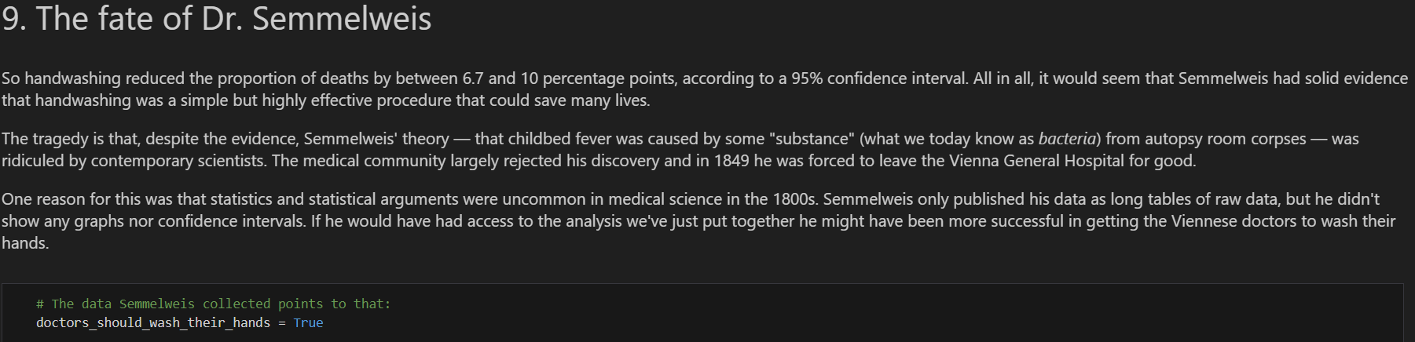

**Challenges Faced and Resolutions**:

The project was a simple one overall, so no challenges faced.

**Conclusion**:

In conclusion, the project was a simple one, in which I used mechanisms like Bootstrap Analysis.